Name: Date:
Period:
Geography Vacation Project

You will be planning a trip around the world for yourself! This project will combine the information you have learned over the week about geography. Your trip will include 3 destinations on 3 different continents, none of which can be in North America. For each destination, you will need to include:
City, Country, Continent
Longitude and Latitude Coordinates
Quadrant
Expected Climate
Population Density
Activities you plan to do (based on geography)
Why you’ve chosen this location

The information will be presented in a tri-fold pamphlet around a map of each location. It should look something like this:
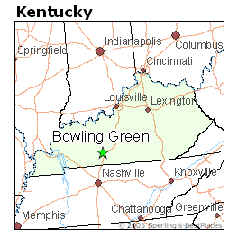
Bowling Green, KY
United States, North America

36.9 N, 86.5 W Activities:
Northwest Quadrant Hiking Trails
Lost River Cave Tour
Average Climate: August Water Sports
66-89 degrees
3.3” Precipitation Population:
~62,500

I chose Bowling Green, KY because there are mountains, lakes, and a temperate climate. It does not seem too hot for August and there will not be a lot of rain.

